

GlowCosmetics online Product selling website

A PROJECT REPORT

SUBMITTED IN PARTIAL FULFILLMENT OF THE REQUIREMENT FOR THE AWARD OF
THE DEGREE OF

MCA (COMPUTER ENGINEERING)
TO
RK UNIVERSITY, RAJKOT

SUBMITTED BY

Name of Student Enrollment No.
Angel Raiyani 24SOECA21089

UNDER THE GUIDANCE OF

Internal Guide Head of Department
Dhaval lal, Dr. Paresh Tanna
RK UNIVERSITY, BCA / MCA
RAJKOT, School of Engineering,
RK University, Rajkot


JULY 2025

SCHOOL OF ENGINEERING, RK UNIVERSITY, RAJKOT

DECLARATION

I hereby certify that I am the sole author of this project work and that neither any part of this project work
nor the whole of the project work has been submitted for a degree to any other University or Institution. I certify that, to the best of my knowledge, my project work does not infringe upon anyone’s copyright nor violate any proprietary rights and that any ideas, techniques, quotations, or any other material from the
work of other people included in my project document, published or otherwise, are fully acknowledged
in accordance with the standard referencing practices. I declare that this is a true copy of my project work, including any final revisions, as approved by my project review committee.

Signature of Student

Angel Raiyani (24SOECA21089),
Date:
Place: Rajkot

INDUSTRY CERTIFICATE

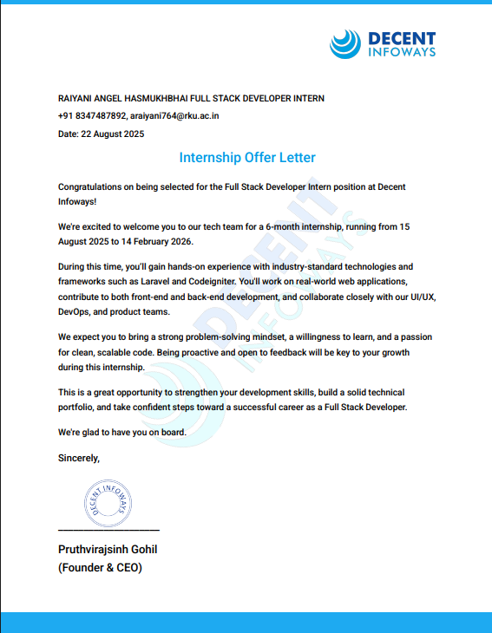



CERTIFICATE

This is to certify that the work which is being presented in the Project Report entitled “GlowCosmetice online product selling website ”, in partial fulfilment of the requirement for the award of the degree of MCA and submitted to the School of Engineering, RK University, is an authentic record of my own work carried out during a period from August 2025 to February 2026. The matter presented in this Project Report has not been submitted by me for the award of any other degree elsewhere.

Signature of Student
Angel Raiyani (24SOECA21089)

This is to certify that the above statement made by the student is correct to the best of my knowledge.

Internal Guide | External Guide | Head of Department
Dhaval Lal | Yash Khungla | Dr. Nirav Bhatt
Assistant Professor, | Co-founder & COO, | CE / IT / BCA / MCA
RK University, | DigiPace Technologies Pvt. Ltd., | School of Engineering,
Rajkot | Vadodara-Gujarat | RK University, Rajkot

April 2023


ACKNOWLEDGEMENT

It has indeed been a great privilege for me to have Mr. Chirag Hirani, ---------------------------------of Decent Infoways Pvt. Ltd., Vadodara, and Mr. Dhaval Lal, Assistant Professor of RK University, as my mentors for this project. His awe-inspiring personality, superb guidance, and constant encouragement are the driving forces behind this project. I take this opportunity to express our utmost gratitude to him. I am also indebted to him for his timely and valuable advice.

I am highly grateful to all the technical and non-teaching staff of the Development Department of Decent Infoways Pvt. Ltd. and Computer Engineering Department of RK University for their constant assistance and cooperation

ABSTRACT
This project presents the design and development of GowCosmetic, an e-commerce web application tailored for cosmetic and beauty product sales. The system is implemented with React for the frontend, Node.js with Express for the backend, and MongoDB as the database, ensuring seamless data management and reliable performance.

The website provides a complete shopping experience with functionalities such as secure user authentication, product browsing with categories, product detail pages, cart and wishlist management, order placement, and integrated payment gateway support. For administrators, the system includes user management, product management (add, edit, delete), offer and category management, and order tracking with status updates, enabling efficient business operations. Real-time features such as dynamic cart updates, order history, and receipt generation further enhance usability.

Designed for deployment as a live e-commerce platform, GowCosmetic emphasizes responsiveness, user-friendliness, and scalability to handle growing business needs. The use of React ensures a dynamic and interactive user interface, while the Node.js backend with MongoDB provides fast processing and accurate record handling.
The expected outcome is a fully functional e-commerce solution that simplifies online shopping for customers, streamlines administrative operations, and supports future scalability. This project highlights how the Full stack (MongoDB, Express, React, Node.js) can be effectively leveraged to build a robust, modern, and business-ready web application.

COMPANY PROFILE

Name of Organization: Decent Infoways
Contact Person Name: Chirag Hirani
Industrial Supervisor Name: Chirag Hirani
Designation: Technical Head
Phone No: +91 9879598095
Email Address: chirag.hirani09@gmail.com
Website: https://decentinfoways.com/
Year of Establishment: 2013
Address: Decent Infoways, Ahmedabad, Gujarat, India
Product Details:
Decent Infoways specializes in custom software development, web applications, mobile apps, and digital solutions. The company delivers tailored IT services to clients worldwide, focusing on quality, innovation, and scalability.
Detail of Testing Facilities:
Comprehensive testing facilities are available for web and mobile application development, including manual testing, automated testing, and performance testing to ensure high-quality deliverables.

COMPANY INFRASTRUCTURE
Company Introduction:
Decent Infoways maintains a modern, efficient, and scalable infrastructure to support its software development and IT services. The company operates with high-performance desktops and laptops, a secure and reliable internet network, and cloud-based platforms such as AWS, Azure, and Google Cloud to ensure flexibility and scalability. For team collaboration, tools like Google Workspace, Microsoft 365, and Slack/Teams are utilized, while Trello and Jira streamline project management. Source code and version control are maintained using GitHub and GitLab.
In terms of security, Decent Infoways implements enterprise-grade antivirus, regular backups, firewalls, and VPN access for remote work. This lean yet powerful infrastructure enables the company to deliver enterprise-level IT solutions efficiently, ensuring quality and scalability as business needs grow.

VISION
At Decent Infoways, our vision is to create a technology-driven world where businesses of all sizes can thrive through innovative, reliable, and secure IT solutions. We aim to become a trusted global partner in digital transformation by offering custom software development, scalable cloud services, and advanced infrastructure solutions that help organizations achieve growth with speed and efficiency.
By fostering a culture of innovation, continuous learning, and ethical practices, Decent Infoways aspires not only to solve today’s business challenges but also to anticipate the opportunities of tomorrow. Our long-term vision is to build sustainable technology ecosystems that connect people, simplify operations, and inspire progress across industries worldwide.

TABLE OF CONTENT

TITLE | PAGE NO.
Company Profile | I
Company Infrastructure | II
1.Introduction | 1
1.1 Project Summary | 1
1.2.Purpose | 1
1.3.Scope | 2
1.4.Technology and Literature Review | 2
1.4.1. Technology Review | 2
1.4.2. Literature Review | 3
2.Project Management | 4
2.1 Project Planning and Scheduling | 4
2.1.1.Project Development Approach | 4
2.1.2.Project Plan | 4
2.2 Risk Management | 5
2.2.1.Risk Identification | 5
2.2.2.Risk Analysis | 5
2.2.3.Risk Planning | 6
3.System Requirement Study | 7
3.1.User Characteristic | 7
3.2.Hardware and Software Requirement | 7
3.3.Constraints | 8
4.System Analysis | 9
4.1.System Analysis | 9
4.2 Study of Current System | 9
4.3.Problem and Weakness of the current System | 9
4.4.Requirement of New System | 10
4.5.Feasibility Study | 10
4.6.Function of the System | 11
5.Testing | 12
5.1 Testing plans | 12
5.2 Testing Strategy | 13
5.3 Testing Cases | 13
6. Screen Shots | 15
7. References | 28

INTRODUCTION

1.1 PROJECT SUMMARY
The GlowCosmetic website is a full-featured e-commerce platform designed for the sale and management of cosmetic and beauty products. It is developed using the MERN stack (MongoDB, Express, React, Node.js), which ensures a dynamic, scalable, and responsive online shopping experience.
The system provides functionalities such as user authentication, product browsing by categories, product detail pages, cart and wish list management, order placement with payment integration, and order history tracking. For administrators, it includes user management, product and category management, offer management, and order status updates, enabling smooth business operations.
The benefits of this e-commerce system include automated order handling, efficient stock and offer management, secure online transactions, and improved customer experience. It is specifically suited for cosmetic businesses looking to expand digitally and serve customers through a reliable, scalable, and user-friendly web solution.

1.2 PURPOSE
⮚ The user can securely register, log in, and manage their account on the website.
⮚ Customers can browse products by categories, view product details, and add items to their cart_or_wishlist.
⮚ The system allows secure checkout and payment processing with automatic order number generation.
⮚ Users can view and track their order history with status updates (e.g., pending, shipped, delivered).
⮚ Administrators can add, update, or delete products, manage offers, categories, and users.
⮚ The website supports better decision-making with features like order management and stock updates.

1.3 SCOPE
The scope of the project is to provide customers with an online platform for purchasing cosmetic products and to give administrators complete control over product, user, and order management. The system covers features such as product catalog browsing, cart and wishlist management, secure order placement with payment, and order history tracking.
It is designed for deployment as a web-based application accessible on desktop and mobile devices. The project is mainly focused on small to medium-sized cosmetic businesses seeking to expand their digital presence and streamline e-commerce operations.

1.4 TECHNOLOGY AND LITERATURE REVIEW

1.4.1 Technology Review:
The GlowCosmetic website is developed using the MERN stack and supporting technologies:
- React.js: Provides a responsive and interactive frontend for product browsing, cart management, and user dashboards.
- Node.js with Express.js: Handles backend logic, order processing, product management, and API routing.
- MongoDB: A NoSQL database used for storing product details, user data, orders, and wishlist items efficiently.
- JWT (JSON Web Token): Ensures secure user authentication and session management.
- REST APIs: Enable communication between the React frontend and Node.js backend, ensuring smooth flow of data.
- Payment Gateway (e.g., Razorpay): Supports secure and real-time transaction handling.

1.4.2 Literature Review:
Research shows that e-commerce platforms have transformed traditional business by providing convenience, scalability, and secure transactions. Online shopping improves customer experience through product accessibility, easy payments, and personalized offers. Studies also highlight the importance of inventory management, order tracking, and user engagement features in retaining customers and ensuring efficient business operations.
E-commerce systems built on the MERN stack provide speed, flexibility, and scalability, making them ideal for small and medium-sized enterprises to expand into digital markets.

PROJECT MANAGEMENT

2.1 PROJECT PLANNING AND SCHEDULING

2.1.1 Project Development Approach
The project followed an Iterative Development Approach for building the GlowCosmetic e-commerce website. The development was carried out in phases where each module—such as user authentication, product management, cart and wishlist, order management, and payment integration—was designed, implemented, and tested separately.
At the end of each phase, testing and feedback were conducted to ensure improvements before proceeding to the next module. This approach was chosen because it provides flexibility, continuous feedback which is critical for building a stable and user-friendly e-commerce platform.

2.1.2 Project Plan
The overall project plan included the following steps:
⮚ Requirement Gathering and Competitor Analysis
⮚ Designing the Website Workflow for Customers and Admin
⮚ Implementing User Authentication and Authorization Modules
⮚ Developing Product Catalos, Cart, Wish list, and Order Features
⮚ Integrating Payment Gateway and Order Tracking System
⮚ Iterative Testing and Debugging for Smooth Performance
⮚ Preparing Deployment and Project Documentation

2.2 RISK MANAGEMENT

2.2.1 Risk Identification
⮚ Data Privacy and Security Risks
⮚ Payment Gateway Risks (failed or fraudulent transactions)
⮚ System Downtime or Server Crashes
⮚ Human Errors in Product or Order Data Entry
⮚ Performance Issues with Large Catalog or High Traffic

2.2.2 Risk Analysis
⮚ Security vulnerabilities:
- Probability: Medium – Risks include weak passwords, SQL/NoSQL injections, or exposed APIs.
- Seriousness: High – Breaches may compromise user accounts, orders, and payment details.
⮚ Payment processing risks:
- Probability: Medium – Issues may arise during failed or incomplete transactions.
- Seriousness: High – Can cause financial discrepancies and loss of customer trust.
⮚ Performance issues:
- Probability: High – With a growing product catalog and high traffic, slowdowns are possible without optimization.
- Seriousness: Medium – Delays in checkout or loading times may reduce customer satisfaction.
⮚ Data quality issues:
- Probability: Medium – Errors may occur in product entry, offers, or order status updates.
- Seriousness: High – Incorrect data can lead to wrong stock levels, billing errors, or customer dissatisfaction.
⮚ System downtime:
- Probability: Low – With proper hosting and monitoring, downtime risk is minimized.
- Seriousness: High – Any downtime impacts order placements and revenue.

2.2.3 Risk Planning
⮚ Security Risks: Implement JWT authentication, password hashing, role-based access control, HTTPS, and input validation. Regularly update dependencies and secure database access.
⮚ Payment Risks: Use trusted gateways (e.g., Razorpay), enable transaction logging, and set up fallback mechanisms for failed payments.
⮚ Performance Risks: Apply database indexing, caching, and pagination for product lists. Use load balancing and monitoring tools for handling peak traffic.
⮚ Data Quality Risks: Enforce input validation for product details, order forms, and user data. Prevent duplicate entries and maintain audit logs for product and order changes.
⮚ System Reliability Risks: Schedule regular backups, use cloud hosting for uptime guarantees, and implement recovery procedures in case of crashes.
⮚ Human Error Risks: Provide training for admins, simplify the admin dashboard UI, and use confirmation prompts for critical actions like deleting products or updating orders.
⮚ Continuous Improvement: Regularly review logs, collect user feedback, release patches to fix bugs, and add improvements for better security and performance.

SYSTEM REQUIREMENT STUDY

3.1 USER CHARACTERISTICS
Admin
Has full control of the GlowCosmetic website.
⮚ Can add, update, and delete products in the catalog.
⮚ Manages special offers, discounts, and promotional banners.
⮚ Can update and manage About Us and Contact Us page details.
⮚ Has access to all registered user details, including their profiles and activities.
⮚ Monitors and manages customer orders, including order status (pending, shipped, delivered, canceled).
⮚ Views analytics such as sales reports, product popularity, and order trends.
Customer/User
⮚ Registers and logs in securely to the GlowCosmetic platform.
⮚ Can browse products by categories such as skincare, makeup, and haircare.
⮚ Searches products using filters (price, brand, rating).
⮚ Adds products to the cart and wishlist for later purchase.
⮚ Places orders, makes payments, and receives order confirmations.
⮚ Can view order history, track delivery status, and manage profile details.
⮚ Has the ability to rate and review purchased products.

3.2 HARDWARE AND SOFTWARE REQUIREMENT
Minimum Hardware Requirement
⮚ Hard Disk: 1 GB of Free Space
⮚ RAM: 2 GB
⮚ CPU: Intel Dual Core Processor or higher
⮚ Operating System: Windows 7 or later, Linux, or macOS (cross-platform support through browser)
Minimum Software Requirement
⮚ Code Editor: Visual Studio Code
⮚ Node.js Runtime: Version 16 or later (for backend)
⮚ MongoDB: Installed locally or connected via MongoDB Atlas (cloud)
⮚ React.js: For building responsive frontend UI
⮚ Browser: Latest versions of Chrome, Firefox, or Edge

3.3 CONSTRAINTS

⮚ Hardware Limitations: The system performance depends on server configuration. Low-end servers may face delays during high traffic.
⮚ Interfaces to Other Applications/Devices: Integrates with third-party payment gateways (e.g., Razorpay). Optional integrations like PDF invoice generation depend on external libraries.
⮚ Reliability Requirements: The system must ensure accurate product, order, and payment records. Any failure may cause financial loss or poor user experience.
⮚ Criticality of the Application: As an e-commerce platform, system uptime is critical to avoid missed sales opportunities.
⮚ Safety and Security Considerations: Uses JWT authentication, password hashing, HTTPS, and role-based access control to prevent unauthorized access.
⮚ Assumptions and Dependencies: Requires stable internet connection, functional hosting server, and properly configured Node.js and MongoDB environment. Relies on third-party payment gateway APIs for secure transactions.

SYSTEM ANALYSIS

4.1 SYSTEM ANALYSIS
The GlowCosmetic website is designed to provide customers with a secure, responsive, and user-friendly online shopping platform for cosmetics. The system uses the MERN stack for development, ensuring modern architecture and scalability.

4.2 STUDY OF CURRENT SYSTEM
Currently, many cosmetic businesses rely on traditional physical stores or outdated websites with limited functionality. The limitations include lack of secure payment integration, absence of analytics, and poor user experience on mobile devices.
The GlowCosmetic project addresses these gaps by offering:
⮚ User Authentication: Secure registration and login with JWT.
⮚ Product Management: Easy product listing, updating, and deletion with categories.
⮚ Cart and Wishlist Management: Customers can add products, modify cart, and save items.
⮚ Order Management: Automated order number generation, checkout, and history tracking.
⮚ Payment Integration: Secure online transactions through Razorpay.
⮚ Admin Dashboard: Full control of users, products, categories, offers, and orders.

4.3 PROBLEMS AND WEAKNESSES OF THE CURRENT SYSTEM
The existing manual or basic websites used by cosmetic businesses have several weaknesses:
⮚ Lack of secure and smooth checkout process.
⮚ No proper order history and tracking system.
⮚ Limited product management and offer customization.
⮚ Poor performance when handling large product catalogs.
⮚ No analytics or reporting to track sales trends.
⮚ Dependency on physical presence, limiting business reach.

4.4 REQUIREMENT OF NEW SYSTEM

The new GlowCosmetic system should:
⮚ Provide a modern, mobile-friendly, and secure e-commerce platform.
⮚ Include real-time product management with offers and categories.
⮚ Support order tracking, secure payments, and invoice generation.
⮚ Provide role-based access (admin, user, staff) for better management.
⮚ Include sales analytics and reporting to help business decisions.
⮚ Offer scalability with cloud hosting to handle large user bases and traffic.

4.5 FEASIBILITY STUDY
⮚ Technical Feasibility: The system uses React, Node.js, Express, and MongoDB — widely supported technologies with large developer communities. The development team has the required skills.
⮚ Market Demand: Cosmetic businesses increasingly require online presence to reach wider audiences. E-commerce websites are in high demand due to changing consumer shopping behaviors.
⮚ Cost Analysis: Development cost is low since MERN stack technologies are open source. Primary costs include hosting, domain, payment gateway fees, and maintenance.
⮚ Scalability: MongoDB supports large datasets, while Node.js and React ensure scalable architecture. Cloud hosting can manage traffic spikes.
⮚ Compatibility: The system runs on all major browsers and devices, making it accessible to a large user base. It integrates with third-party APIs for payment and communication.
⮚ Security: JWT authentication, role-based access, and encrypted transactions safeguard sensitive customer and business data.

. FUNCTION OF THE SYSTEM

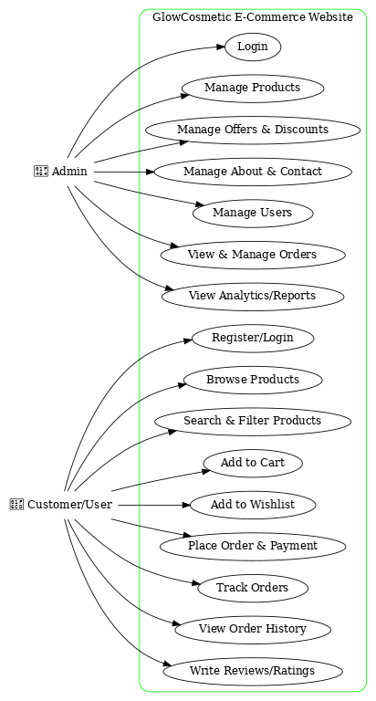

Testing

5.1 Testing Plan
- Unit Testing
- Test individual components like login, signup, product listing, and checkout.
- Use tools like Jest (React) and Mocha/Chai (Node.js) for automated tests.
- Integration Testing
- Ensure smooth data flow between frontend, backend, and database.
- Test API endpoints for users, products, offers, cart, and orders with Postman or Supertest.
- System Testing
- Validate complete system functionality as per requirements.
- Test end-to-end flows such as browsing products, adding to cart, placing an order, and payment processing.
- Performance Testing
- Check website speed and behavior under high load (multiple users/orders).
- Measure response time for product search, cart updates, and checkout.
- Security Testing
- Test for vulnerabilities like XSS, CSRF, and SQL/NoSQL injection attacks.
- Verify secure authentication, password hashing, and role-based access.
- User Acceptance Testing (UAT)
- Involve real users/customers to test usability, design, and features in a live environment.
- Ensure smooth navigation, easy checkout, and reliable order placement.

5.2 Testing Strategy
- Black Box Testing
- Focus on testing features without looking into internal code.
- Verify system responses for inputs like product search, login, and order placement.
- White Box Testing
- Developers test internal code logic and APIs.
- Includes unit tests, code coverage checks, and business logic validation.
- Manual Testing
- Manually test the website’s interface, responsiveness, and cross-browser compatibility.
- Verify product pages, checkout flow, and payment gateway integration.
- Automated Testing
- Use Jest, Cypress, or Selenium for repeated test cases.
- Automate login, add-to-cart, checkout, and admin dashboard workflows.

5.3 Testing Cases
- Homepage
- Verify homepage loads quickly without errors.
- Ensure featured products, offers, and banners display correctly.
- User Registration and Login
- Validate all required fields in the signup form.
- Test login with valid and invalid credentials.
- Product Browsing & Cart
- Add products to the cart and check accurate price/offer calculations.
- Test removing or updating items in the cart.
- Verify cart updates reflect in the database.
- Order Placement & Payment
- Ensure order is saved correctly in the database.
- Confirm order ID and success message are generated.
- Test payment flow with valid/invalid inputs and proper error handling.
- Admin Dashboard
- Test admin login with role-based access.
- Verify admin can manage users, products, offers, and orders.
- Ensure admin can update or delete product details and offers.

SCREENSHOTS

6.1 Login Screen
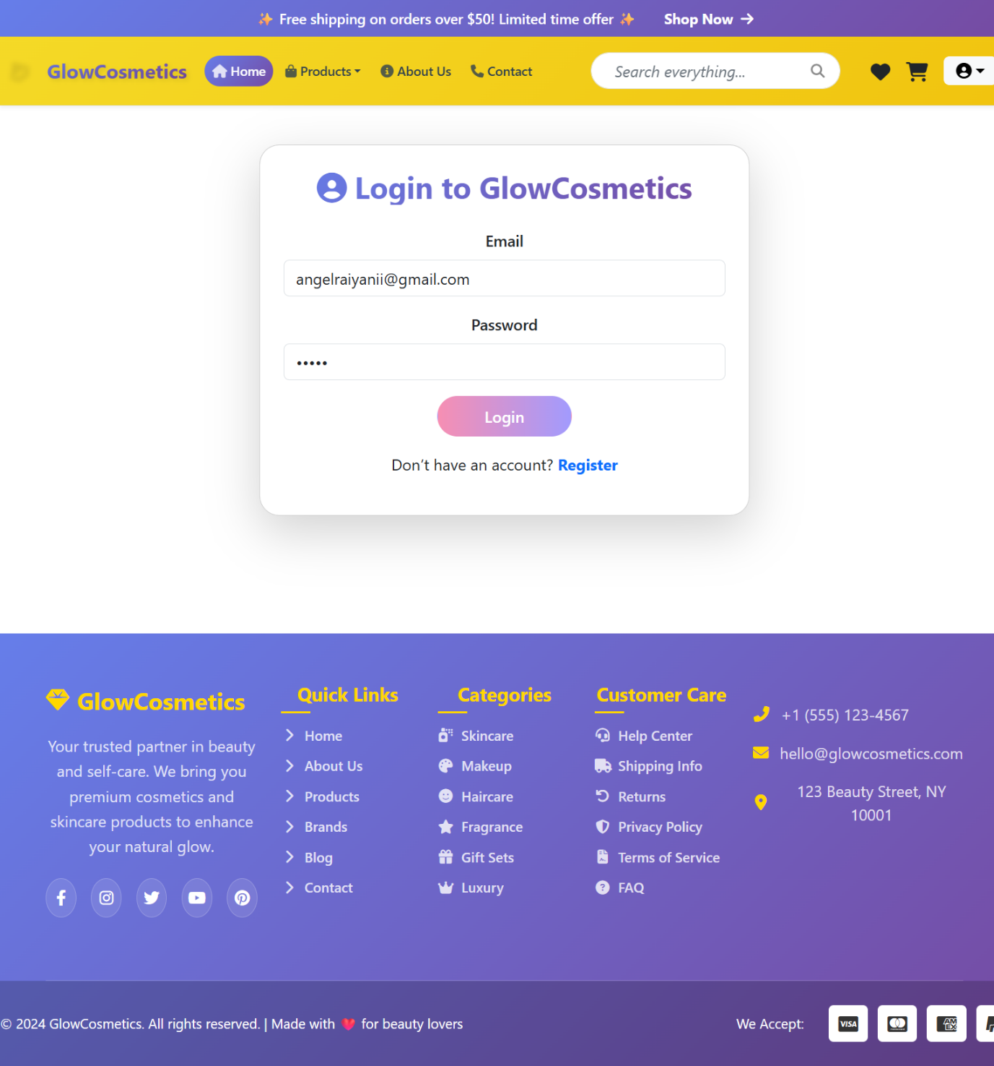
- Shows user/admin login functionality with secure authentication.

6.2 Signup / Registration Screen
- User registration form for creating a new account.
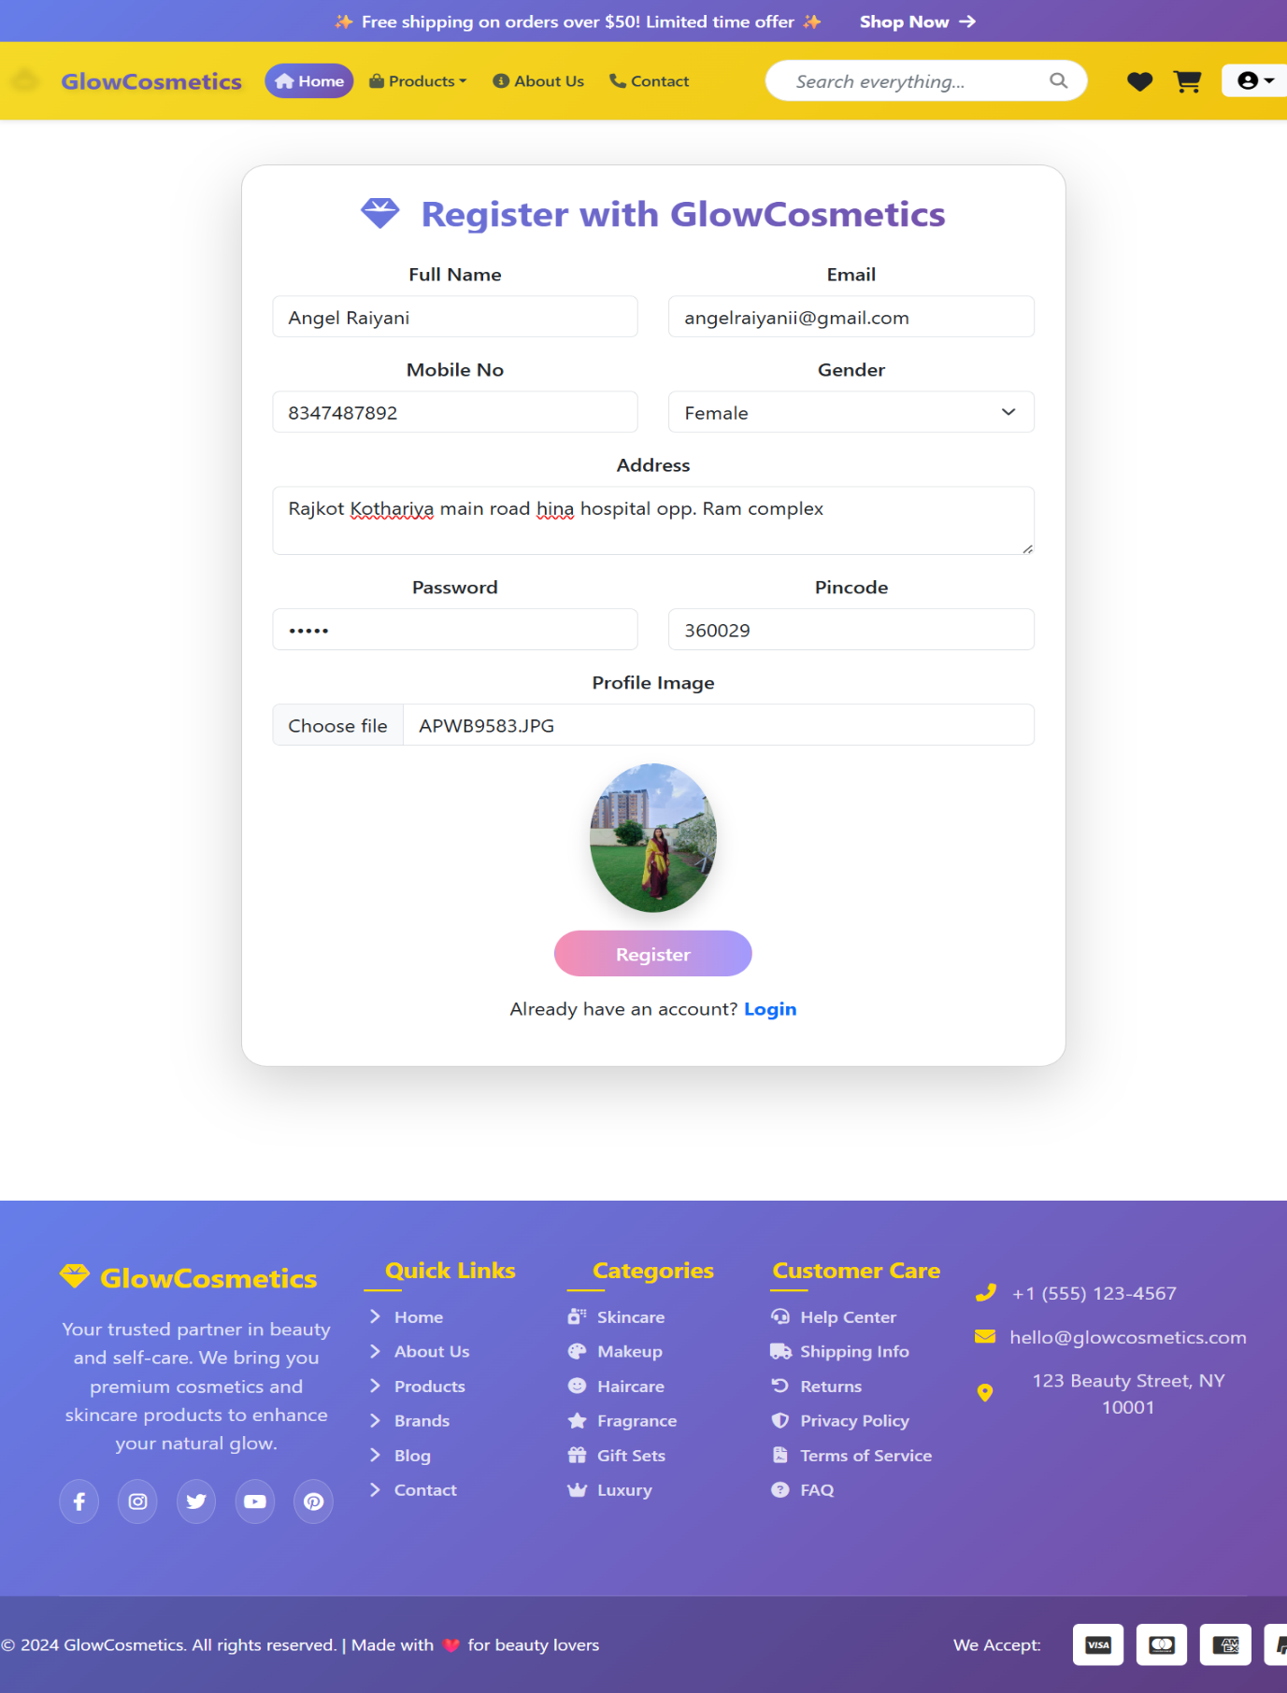

6.3 Homepage
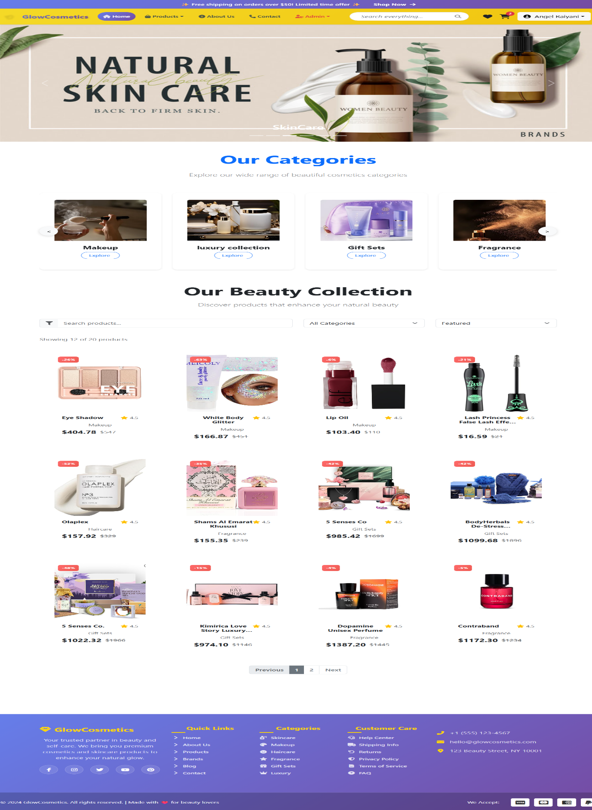
- Displays featured products, banners, and offers.

6.4 Product Listing Page
- Shows available products with categories, filters, and add-to-cart option.
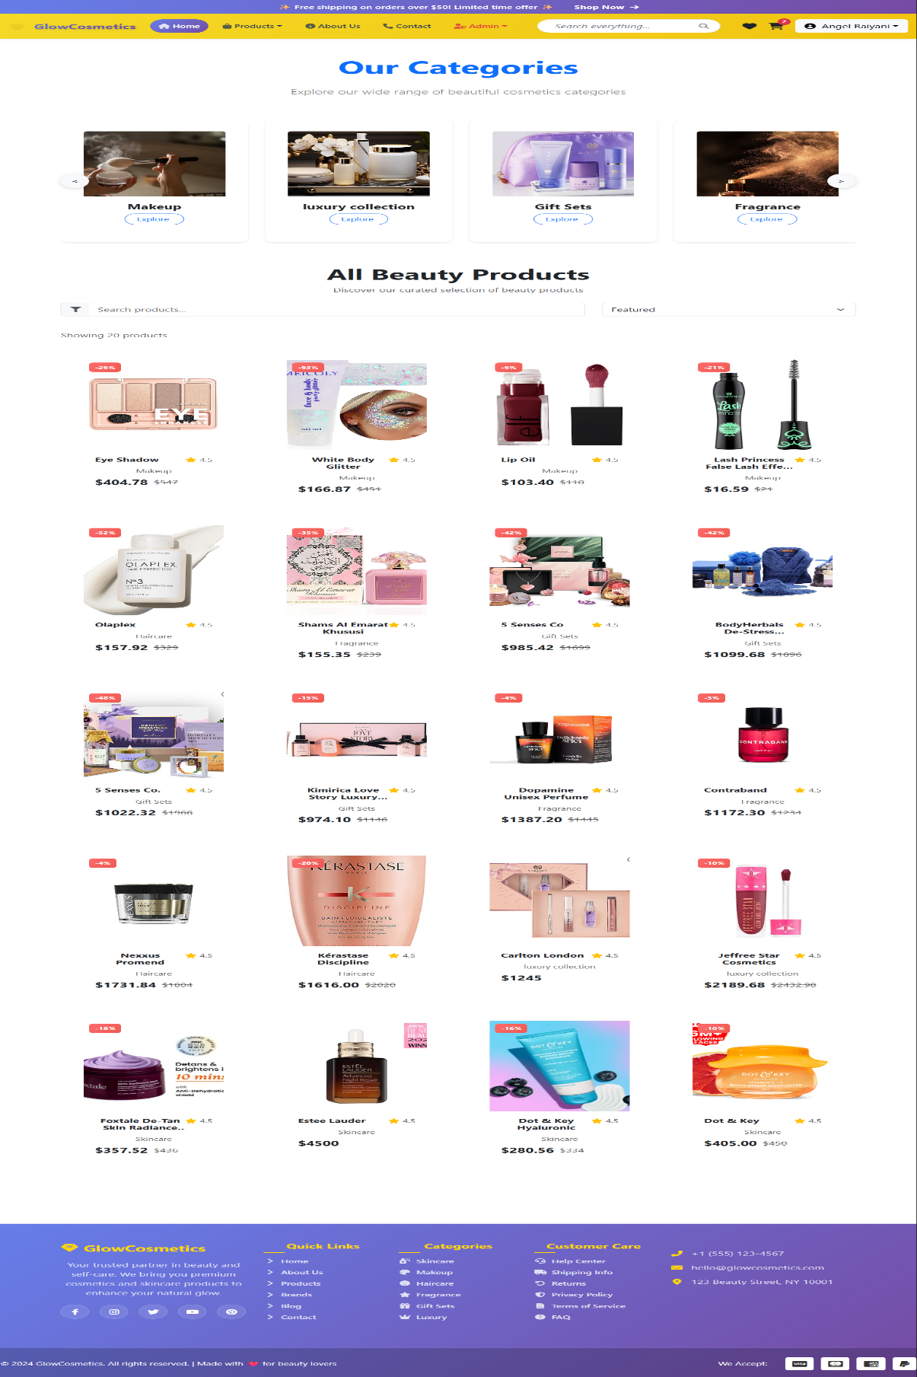

6.5 Category wise Product

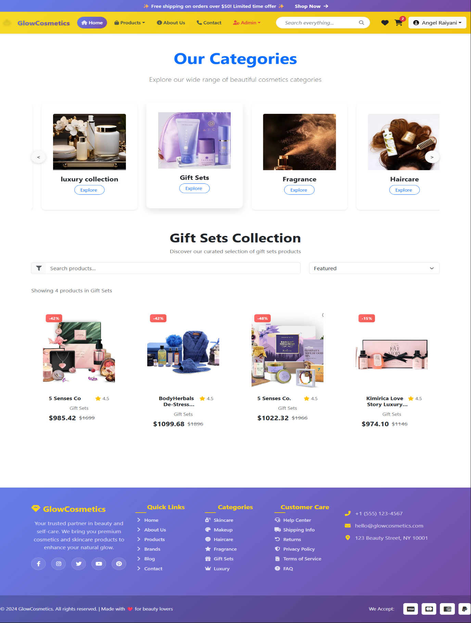
Displays Product category wise like feature product

6.6 Product Details Page
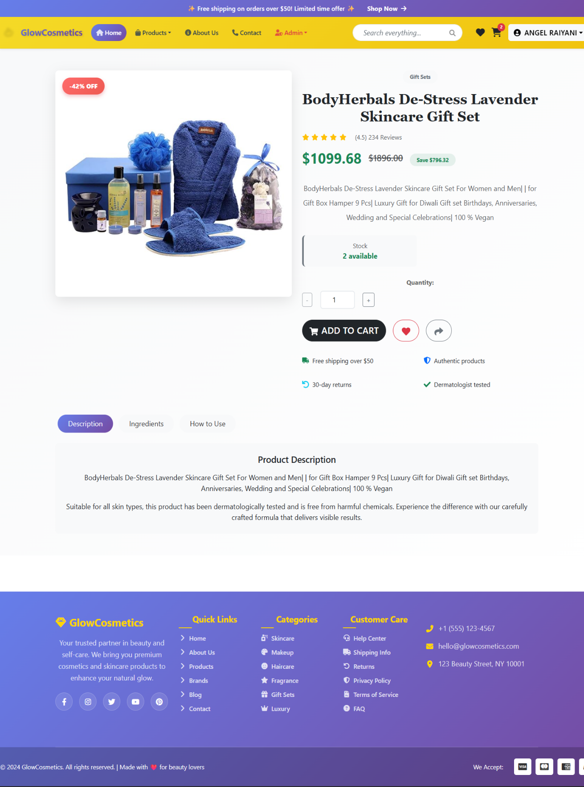
- Displays detailed product description, price, and add-to-cart option.

6.7 Cart Page
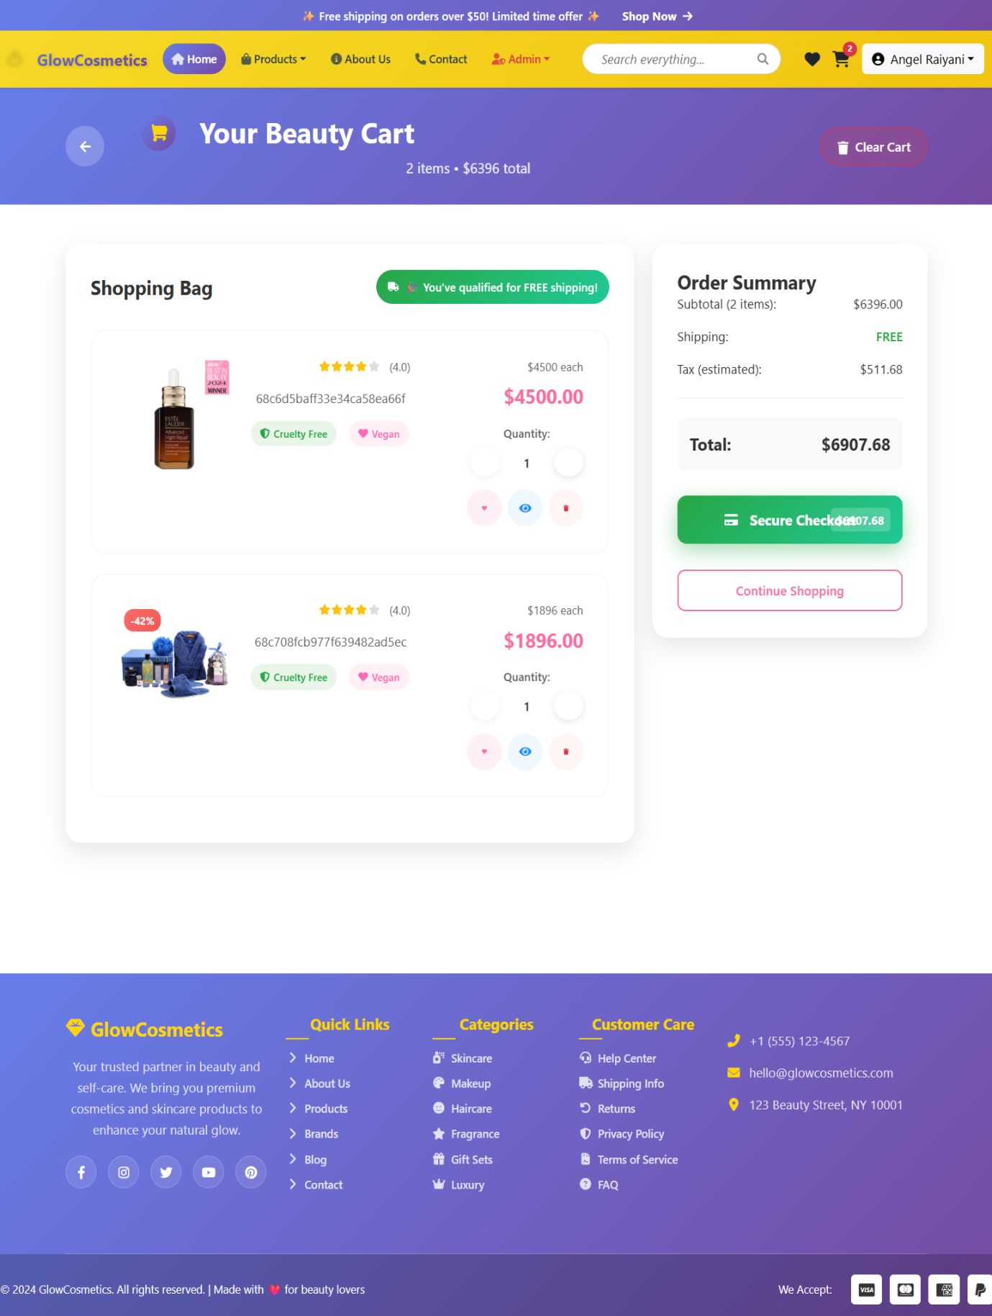
- Shows selected items with quantity update and total calculation.

6.8 Checkout Page

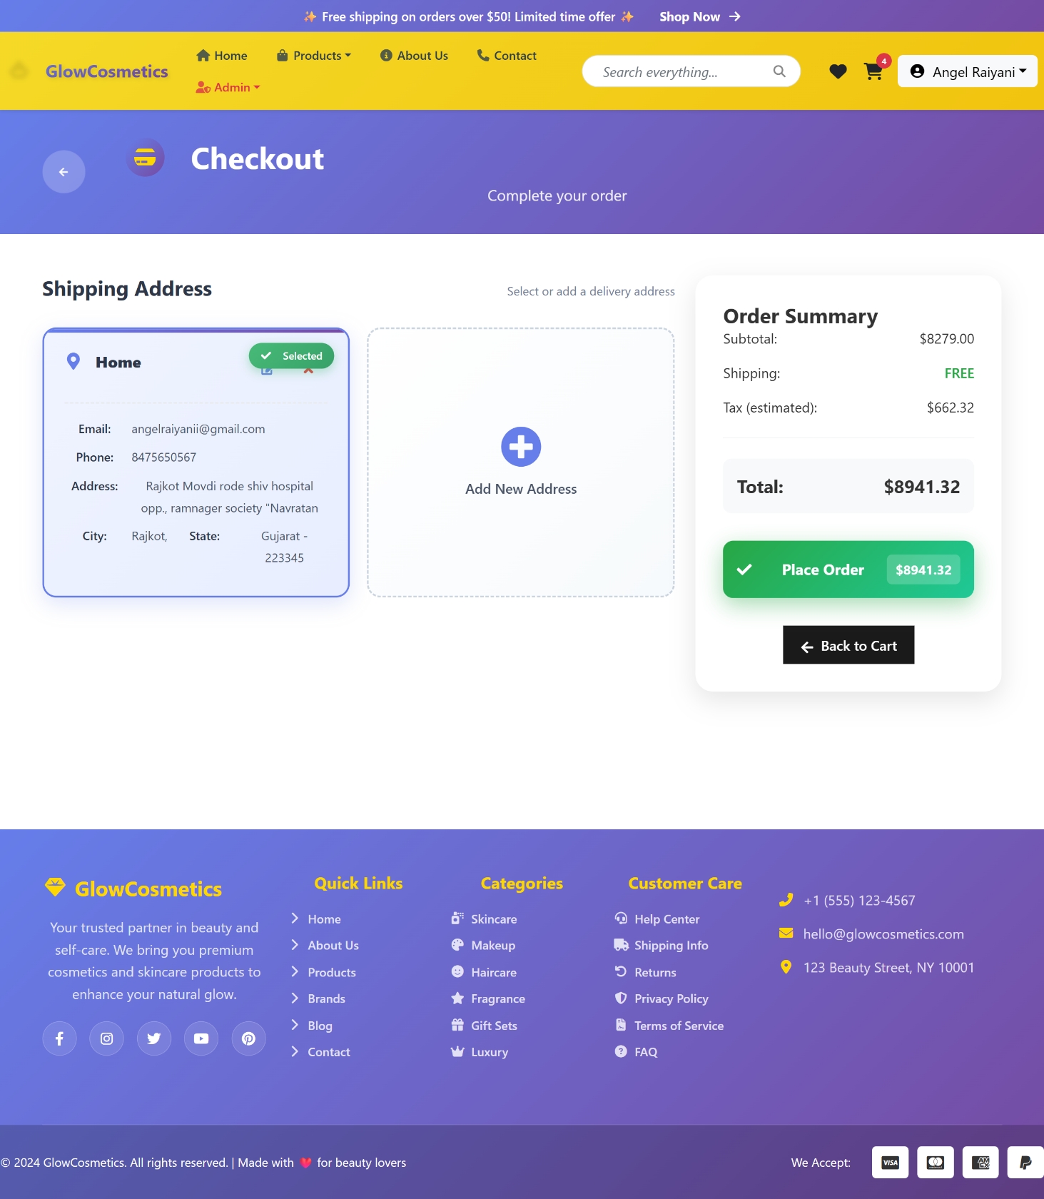

6.9 Wish list Page
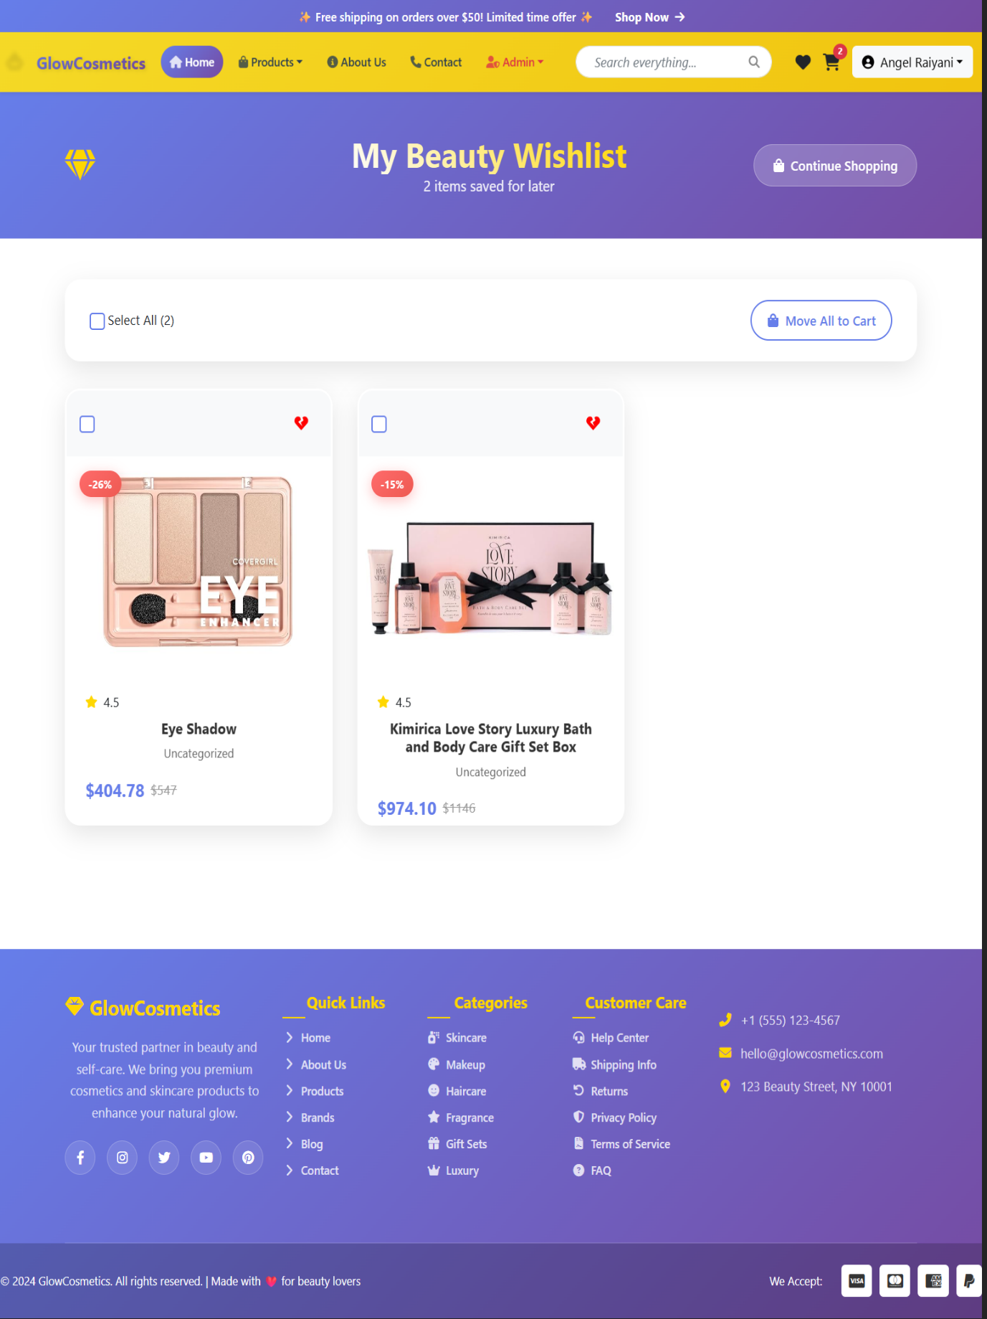
- Shows User her liked product.

6.10 User Profile / Account Page
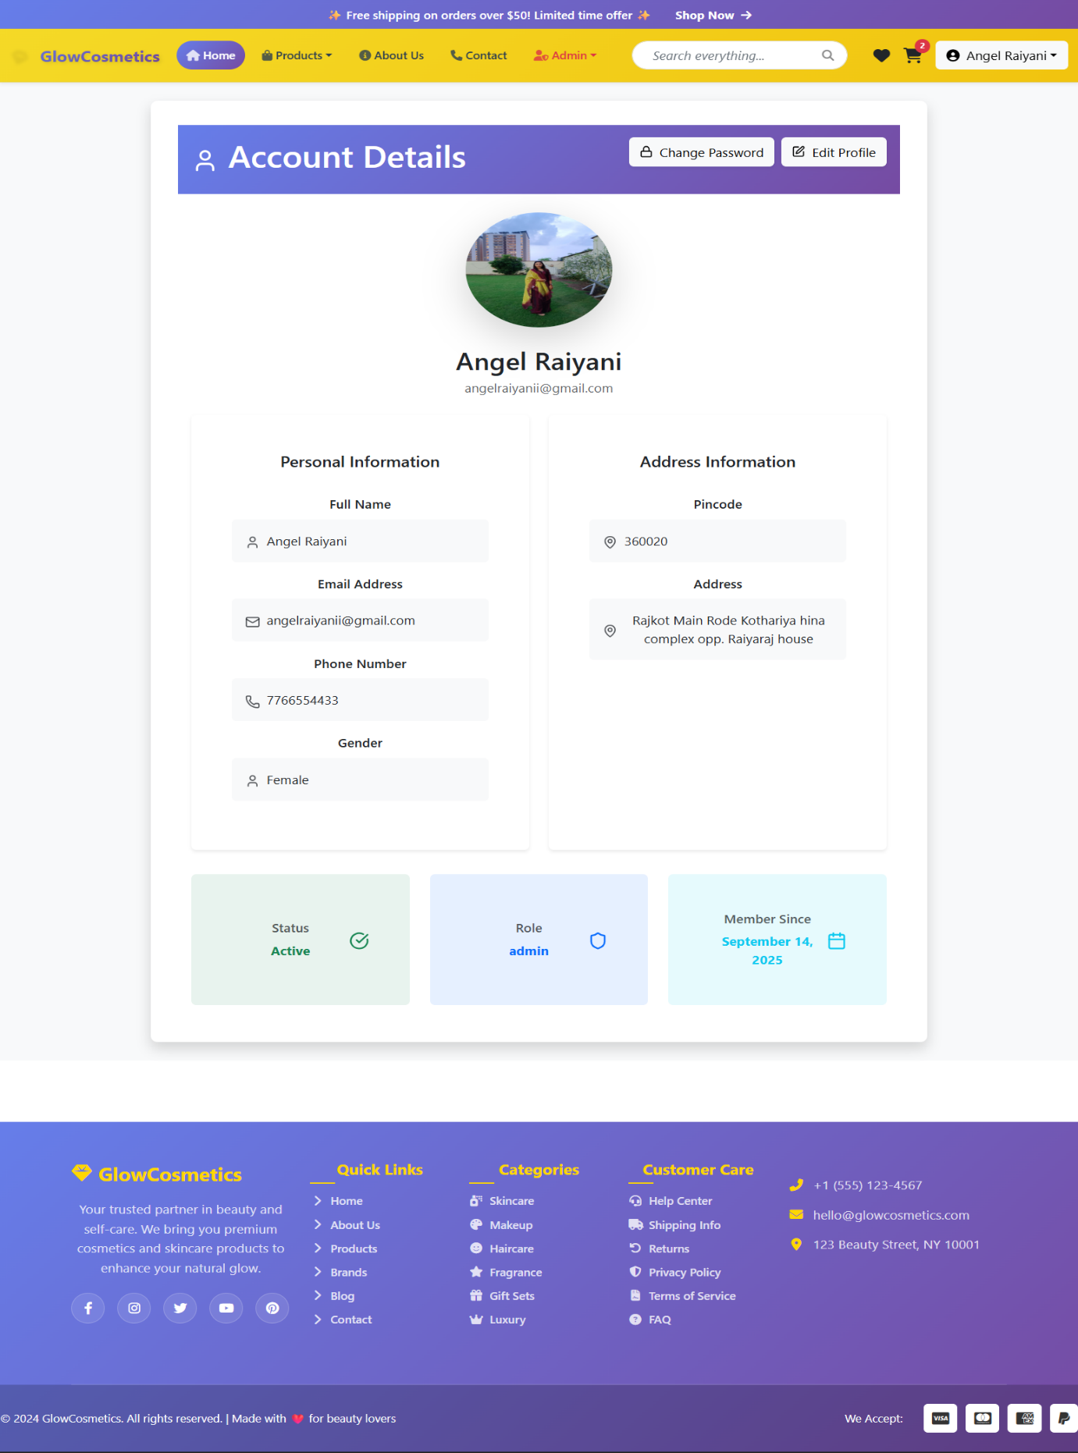
- Allows users to view and update their details, addresses, and password.

6.11 About Us Page
- Displays company introduction, mission, and brand details for GlowCosmetic.
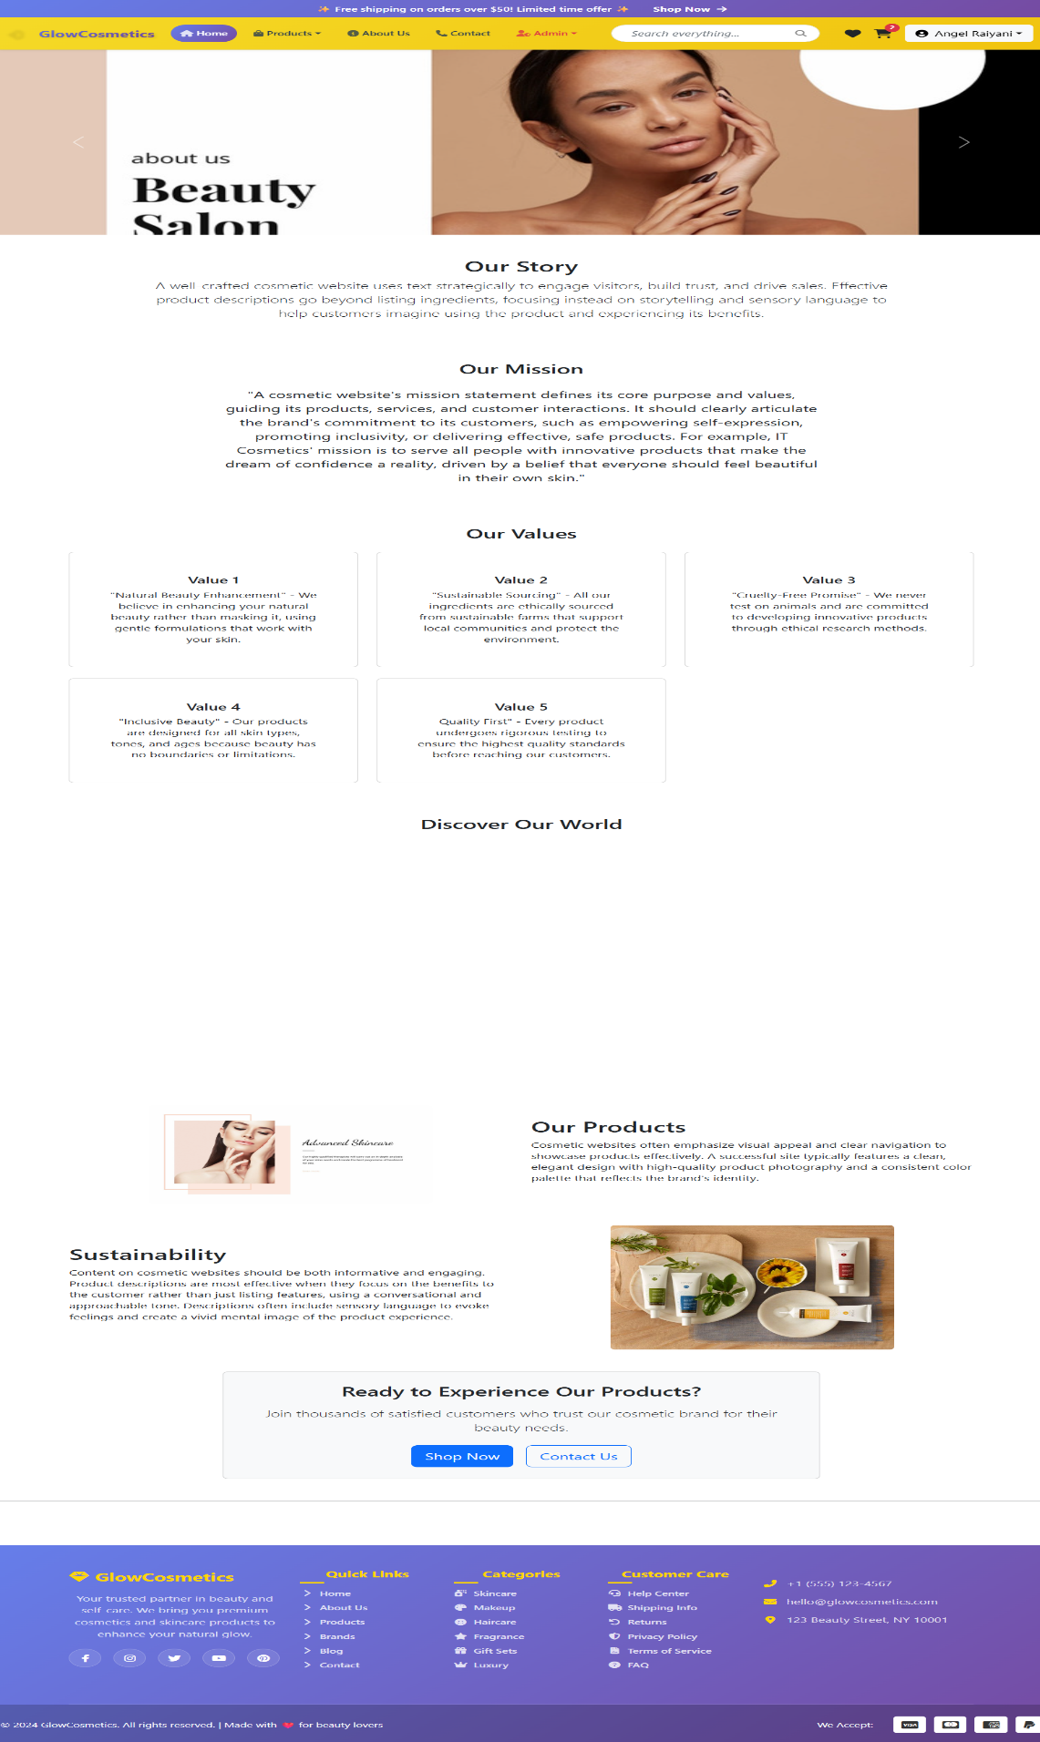

6.12 Manage Products (Admin)
- Screen for adding, updating, or deleting products.
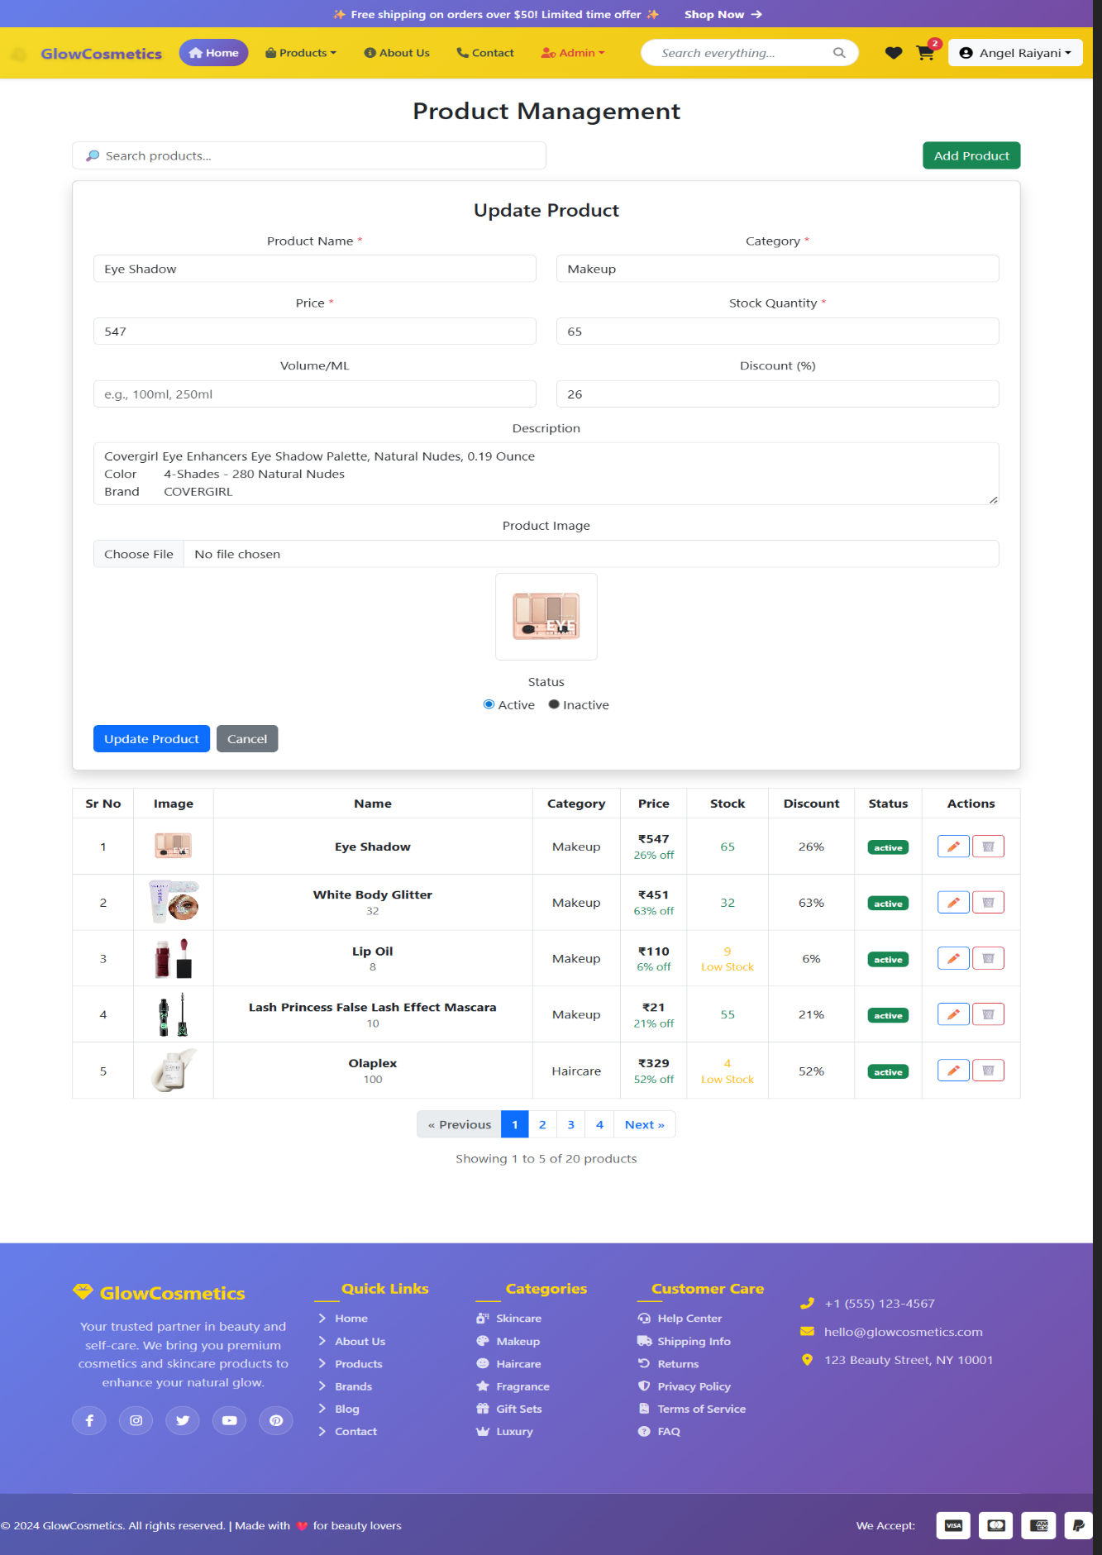

6.13 Manage Category (Admin)
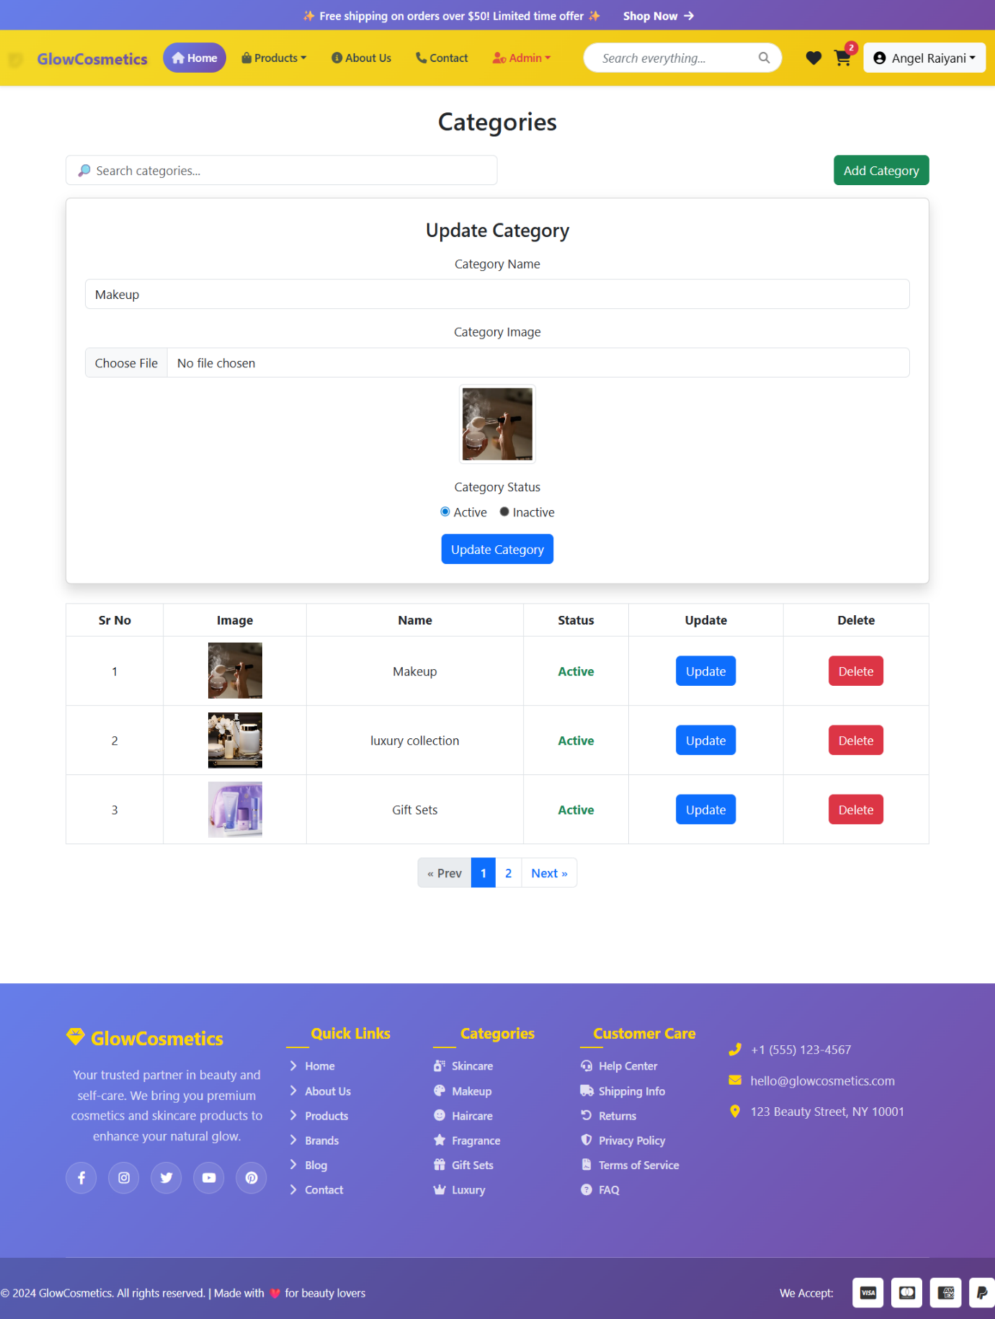
- for adding, updating, or deleting category.

REFERENCE

• Google
• Node.js
• MongoDB
• Razor pay
• Gemini Ai
• ChatGPT
• W3Schools
• Bootstrap
• Myntra
• Stack Overflow
• FlipKart
• Google

